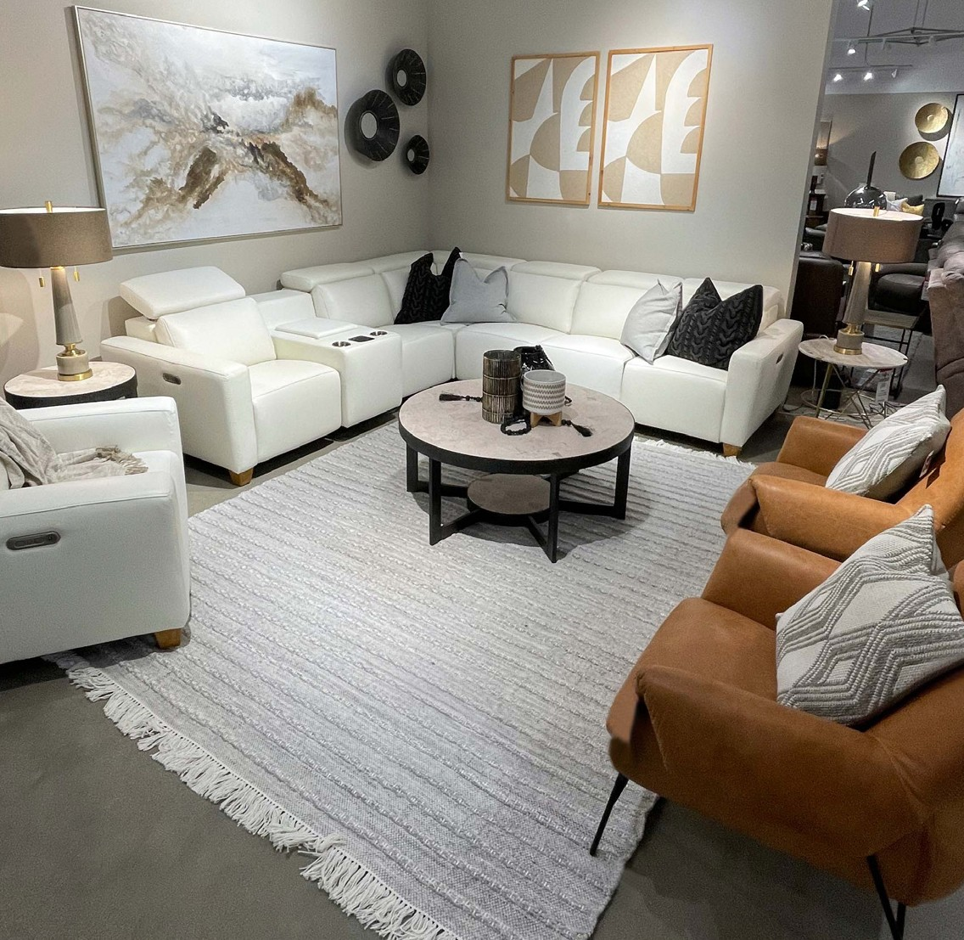
Sweepstakes
Chance to win $5000.
Room Makeover

Since 1888, spanning over 134 years and five generations, Montgomery’s has provided the region with quality, stylish home furnishings. Owned and
operated by 4th and 5th generation family members, Clark, Connie, Eric, and Neala Sinclair, Montgomery’s has showrooms in Watertown, Madison, Sioux Falls, and Aberdeen.

LEARN MORE ABOUT WATERTOWN AREA UNITED WAY

LEARN MORE ABOUT MONTGOMERY’S

Montgomery’s offers the true
whole-home experience with furniture, flooring, window fashions, lighting, mattresses, and complimentary
design services. Montgomery’s believes in giving back to local communities and is excited to donate the once again
$5,000 room makeover.
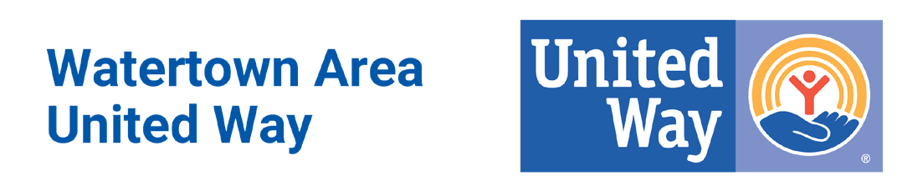
GIVE TODAY.
CHANGE TOMORROW.
DONATE FOR A CHANCE
TO WIN $5,000!

OUR 2023-2024 CAMPAIGN GOAL IS $550,000!

Give Today. Change Tomorrow.

THINK ABOUT IT.
$1 PER WEEK

IS ALL IT TAKES TO MAKEOVER A COMMUNITY!

One dollar a week ($52) can barely buy a tank of gas, but a $52 donation to the Watertown United Way can change tomorrow. By giving to your local United Way, you can help local families, individuals, youth, and seniors when in a crisis or in need of basic human needs such as food, shelter, healthcare, and education.

By giving only $1 a week to the Watertown United Way, you could win a $5,000 room makeover from Montgomery’s!

HOW TO ENTER

By contributing in one of these three ways your name will be entered into the $5,000 Room Makeover donated by Montgomery’s. See official rules on next page.
Three ways to enter:
- Donate at least $52 or more
as a first-time giver.
- Increase your annual giving by
$52 or more as a current giver.
- Join our Heart Club! Heart Club members give a minimum of $500 annually.

BE SURE TO ATTEND THE END- OF-CAMPAIGN WRAP UP AT MONTGOMERY’S IN WATERTOWN!

IF THE $5,000 ROOM MAKEOVER SWEEPSTAKES WINNER IS PRESENT FOR THE DRAWING, THEY WILL RECEIVE AN EXTRA $500!

OFFICIAL RULES

NO PURCHASE OR DONATION NECESSARY TO ENTER OR WIN. PURCHASE OR DONATION WILL NOT
INCREASE CHANGES OF WINNING. Odds of winning depends on the number of eligible entries received. United Way Sweepstakes (the “Sweepstakes”) begins on August 1, 2023, and ends on January 31, 2024 (“Promotional Period”). Must be a legal resident of the United States,18 years of age or older when the Sweepstakes begins. Enter one of two ways: (1) complete an official United Way entry form, your pledge card from the United Way will serve as your official entry form, when you make a first time donation to the Watertown Area of United Way of $52.00 or more, or increase your previous year’s donation by $52.00 or more during Promo- tional Period; or (2) hand print your complete name, address, city, state, zip code, date of birth, daytime telephone number, and email address (optional) on a “3x5” card. Entry forms received from an employer
should be returned to that employer, all other entries should be mailed in a first class stamped envelope to: Watertown Area United Way, 818 S. Broadway, Suite 100, P.O. Box 283, Watertown, SD 57201. Entries must be postmarked or received by January 31, 2024. Limit to one (1) entry per person. The approximate retail value of all prizes is $5,000. A valid driver’s license will be re- quired prior to taking delivery of the prize. The winner is solely responsible for all applicable taxes, (including, but not limited to, federal income taxes), and other expenses that may be required for the enjoyment and use of the prize. Void in New York, Florida, Rhode Island, Puerto Rico, and where prohibited. These sweepstakes are sponsored by the Watertown Area United Way, 818 S. Broadway, Suite 100, P.O. Box 283, Watertown, SD 57201, and Montgomery’s Watertown, 1000 9th Ave SE, Watertown, SD, 57201 (collectively, the “Sponsors”). By participating in the Sweepstakes entrants agree to: (1) abide by and be bound by the full official Rules, available at www.watertownunit- edway.org (2) to release the Released Parties (as defined in the Official Rules) from all liability related to the participation in the Sweepstakes or arising from the prize awarded; and (3) the decisions of the Sponsors and acknowledge and agree that the Sponsors may collect the personal information submitted by entrant, and use the information pursuant to the Sponsors’ privacy policies available by calling 605- 886-5815. Please see the Official Rules for complete details and qualifications.

